ASSIGNMENT – 8 (HTML) (KASHISH)
Q-1 Create a Bootstrap layout for a Flipkart-style product card page: use a container with a row, and display three product cards side by side using the grid system's columns?
Ans.
<!DOCTYPE html>
<html lang="en">
<head>
<meta charset="UTF-8">
<!-- Makes the webpage responsive on mobile devices -->
<meta name="viewport" content="width=device-width, initial-scale=1.0">
<title>Flipkart Product Card</title>
<style>
body {
font-family: Arial, sans-serif;
background-color: #f1f3f6;
margin: 0;
padding: 20px;
}
.product-card {
width: 90%;
max-width: 300px;
margin: auto;
background-color: white;
border-radius: 10px;
padding: 15px;
text-align: center;
box-shadow: 0 2px 8px rgba(0, 0, 0, 0.2);
}
.product-card img {
width: 100%;
height: auto;
border-radius: 5px;
}
.product-card h2 {
font-size: 22px;
margin: 10px 0;
}
.price {
color: green;
font-size: 20px;
font-weight: bold;
}
.product-card button {
background-color: #ff9f00;
color: white;
border: none;
padding: 10px 20px;
margin-top: 10px;
font-size: 16px;
border-radius: 5px;
cursor: pointer;
}
.product-card button:hover {
background-color: #fb8c00;
}
</style>
</head>
<body>
<div class="product-card">
<img src="/Headphone.avif" alt="Product Image">
<h2>Wireless Headphones</h2>
<p>High-quality sound with comfortable design.</p>
<p class="price">₹1,999</p>
<button>Add to Cart</button>
</div>
</body>
</html>

Result:
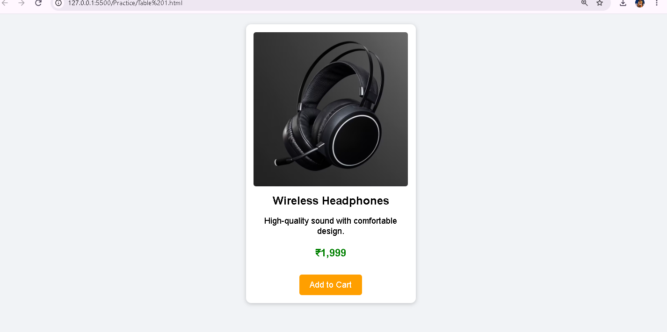

Q-2 Build a Zomato restaurant listing page using Bootstrap grid: arrange two restaurant cards per row, each card showing a restaurant name and a short description.<br><br><em><strong>Hint:</strong> Use col-6 inside a row to get two equal columns per row.</em>?
Ans.
<!DOCTYPE html>
<html lang="en">
<head>
<meta charset="UTF-8">
<!-- Makes the page responsive on mobile devices -->
<meta name="viewport" content="width=device-width, initial-scale=1.0">
<title>Responsive Flipkart Product Card</title>
<style>
body {
font-family: Arial, sans-serif;
background-color: #f1f3f6;
margin: 0;
padding: 20px;
}
/* Product Card - Horizontal Layout */
.product-card {
display: flex;
align-items: center;
gap: 20px;
max-width: 700px;
margin: auto;
background-color: white;
padding: 20px;
border-radius: 10px;
box-shadow: 0 2px 8px rgba(0, 0, 0, 0.2);
}
/* Product Image */
.product-card img {
width: 250px;
height: 200px;
object-fit: cover;
border-radius: 8px;
}
/* Product Details */
.product-details {
flex: 1;
}
.product-details h2 {
margin-top: 0;
}
.price {
color: green;
font-size: 22px;
font-weight: bold;
}
button {
background-color: #ff9f00;
color: white;
border: none;
padding: 10px 20px;
font-size: 16px;
border-radius: 5px;
cursor: pointer;
}
/*Mobile Layout */
@media (max-width: 600px) {
.product-card {
flex-direction: column;
text-align: center;
}
.product-card img {
width: 100%;
height: auto;
}
}
</style>
</head>
<body>
<div class="product-card">
<img src="/Headphone.avif"
alt="Wireless Headphones">
<div class="product-details">
<h2>Wireless Headphones</h2>
<p>
Enjoy high-quality sound with a comfortable and stylish design.
</p>
<p class="price">₹1,999</p>
<button>Add to Cart</button>
</div>
</div>
</body>
</html>

Result:
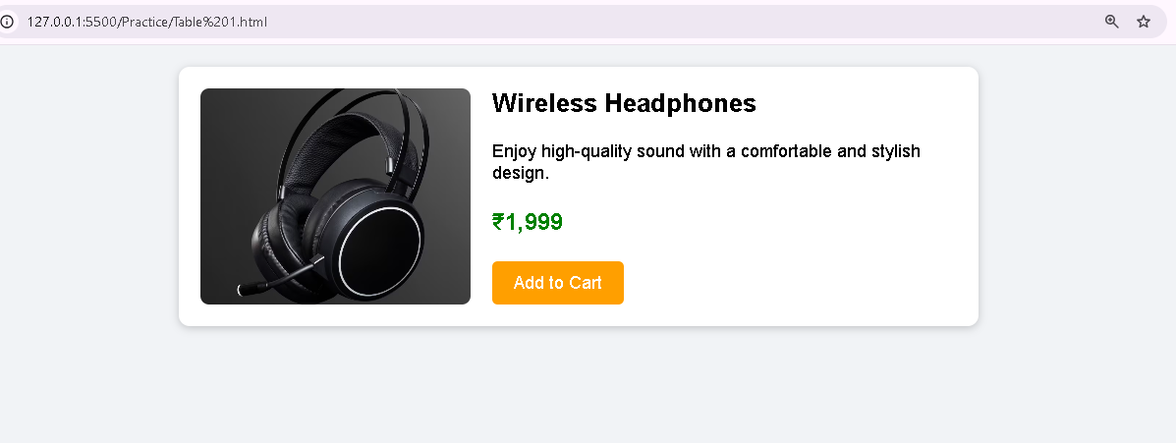

Q-3 Design a BookMyShow-like movie details section using Bootstrap: place a movie poster image in one column and movie details (title, genre, rating, and a 'Book Now' button) in the second column, using the grid system?
Ans.
<!DOCTYPE html>
<html lang="en">
<head>
<meta charset="UTF-8">
<meta name="viewport" content="width=device-width, initial-scale=1.0">
<title>Responsive Product Card</title>
<style>
body {
font-family: Arial, sans-serif;
background-color: #f1f3f6;
margin: 0;
padding: 20px;
}
/* Default Product Card */
.product-card {
display: flex;
align-items: center;
gap: 20px;
max-width: 700px;
margin: auto;
background-color: white;
padding: 30px;
font-size: 20px;
border-radius: 10px;
box-shadow: 0 2px 8px rgba(0, 0, 0, 0.2);
}
.product-card img {
width: 250px;
height: 200px;
object-fit: cover;
border-radius: 8px;
}
.product-details {
flex: 1;
}

.price {
color: green;
font-weight: bold;
}
button {
background-color: #ff9f00;
color: white;
border: none;
padding: 10px 20px;
font-size: 16px;
border-radius: 5px;
cursor: pointer;
}
/* Breakpoint: 1200px or less */
@media only screen and (max-width: 1200px) {
.product-card {
font-size: 18px;
padding: 25px;
}
}
/* Breakpoint: 900px or less */
@media only screen and (max-width: 900px) {
.product-card {
font-size: 16px;
padding: 20px;
}
}
/* Breakpoint: 600px or less */
@media only screen and (max-width: 600px) {
.product-card {
flex-direction: column;
text-align: center;
font-size: 14px;
padding: 15px;
}
.product-card img {
width: 100%;
height: auto;
}
}
</style>
</head>
<body>
<div class="product-card">
<img src="/Headphone.avif"
alt="Wireless Headphones">

<div class="product-details">
<h2>Wireless Headphones</h2>
<p>
Enjoy high-quality sound with a comfortable and stylish design.
</p>
<p class="price">₹1,999</p>
<button>Add to Cart</button>
</div>
</div>
</body>
</html>

Result:
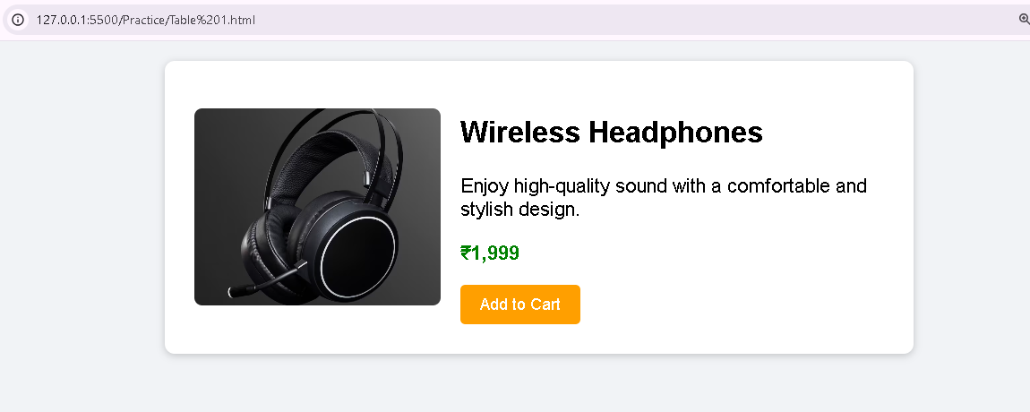

Q-4 Refactor your 2-column layout to be mobile-friendly: make the columns stack vertically on screens smaller than 576px using Bootstrap's responsive grid classes.<br><br><em><strong>Hint:</strong> Try using col-12 for xs and col-6 for md and above.</em>?
Ans.
<head>
<meta name="viewport" content="width=device-width, initial-scale=1.0">
<style>
/* Your normal CSS */
.product-card {
display: flex;
padding: 30px;
font-size: 20px;
}
/* Put the breakpoints here */
@media only screen and (max-width: 1200px) {
.product-card {
padding: 25px;
font-size: 18px;
}
}
@media only screen and (max-width: 900px) {
.product-card {
padding: 20px;
font-size: 16px;
}
}
@media only screen and (max-width: 600px) {
.product-card {
flex-direction: column;
padding: 15px;
font-size: 14px;
}
}
</style>
</head>
